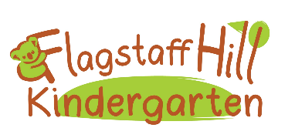Safe Sleeping
Rationale
At Flagstaff Hill Kindergarten we promote opportunities for rest and relaxation time. This rationale of this policy is to create a safe, positive and relaxed atmosphere for children to rest their bodies.
The Department for Education (DfE) has a primary document ‘Safe sleeping and resting for infants and young children’ which is the guiding document.

Our Kindergarten will:
- Provide a relaxation time after lunch for children to rest their bodies. This may take the form of yoga movements, listening to an audio story, breathing exercises or movement experiences. As per the Child Protection Curriculum children will be encouraged to lie down but should this be against their wishes they can choose to sit instead.
- After relaxation time children will transition from the map room to quiet experiences before being offered outdoor play experiences. This allows children some slow down time to rest their bodies further.
- Lounges and cushions will be provide both inside and outside so children have the opportunities to come lie down should they feel tired.
- Should a child require a sleep as part of their Kindergarten time this will be negotiated with families as part of the enrolment process. If a child is required to sleep we will ensure an educator is close to the room at all times. We will remove necklaces and loose clothing and ensure that the lighting and temperature is no greater than 22°c.

As per SIDS Sleeping Practices, educators will:
- Keep the Centre a smoke-free environment. Staff who smoke and work directly with children are required to wear an item of clothing as an outer layer while smoking that is removed upon returning to the Kindergarten to work with children. Before re-commencing work, educators should remove the smell of smoke from their person as much as possible (e.g. washing their hands, drinking water etc.).

Families will:
- Negotiate a sleep plan with the Kindergarten Director on enrolment. If their child has a sleep routine that is different to this policy and the recommendations of SIDS and Kids before implementing any sleep plans, the Kindergarten may require the plan be signed off by a medical professional.
- Provide bedding for the child including a sheet, blanket and any comforters e.g. teddy

R168(2)(a)(v) Sleep and rest
National Quality Standards 2.1.2

Approved by Educators and the Governing Council August 2021
To be reviewed 2024
Governing Council Chairperson: ___________________________
Kindergarten Director: ___________________________________

